**Convert Octal to Decimal**

**EXP NO 30**

#include<stdio.h>  
#include<math.h>  
int Octal To Decimal(int n) {  
   int p = 0, decimal = 0, r;  
     
   while(n>0){  
          
        // retrieving the right-most digit of n  
        r = n % 10;  
          
        // dividing n by 10 to remove the  
        // right-most digits since it is already  
        // scanned in previous step  
        n = n / 10;  
          
        decimal = decimal + r * pow( 8 , p );      
        ++p;  
          
   }  
     
   return decimal;  
}

int main() {

   int n, i, k;

   print f("Enter Octal: ");

   scan f("%d", &n);

   print f("\n Decimal of Octal Number %d is : %d", n, Octal To Decimal(n));

   return 0;

}

**INPUT :**

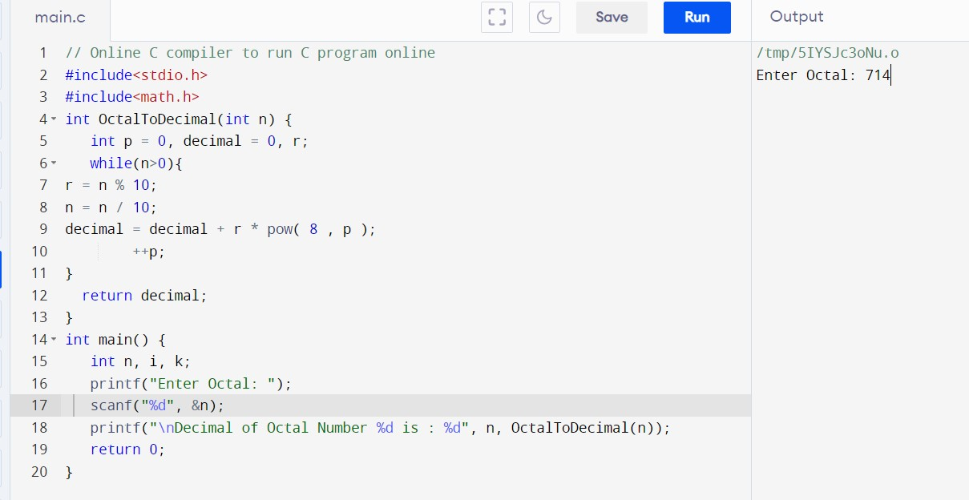

**OUTPUT:**

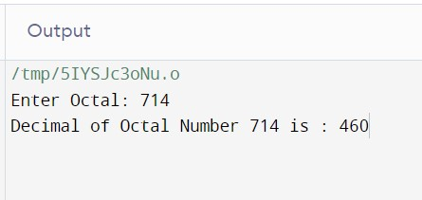

**RESULT:**Thus the program was executed successfully using Dev C++.